
June 7, 2024
Firearm injury & suicide prevention: KPWA offering free firearm cable locks starting June 17, 2024
Questions about this article?
- Rebecca Parrish, LICSW, MSW, Administrator, MHW Clinical Operations
- Julie Angerhofer Richards, PhD, MPH, Assistant Investigator, KPWA Research Institute

Why are we offering firearm locking devices?
In Washington state, 42% of households report having firearms. The most common reason people report owning firearms is for protection, but firearms are also the leading cause of death for children and teens (age 1-19) and the most common way people of all ages die by suicide. Research shows providers often have valuable opportunities to help patients learn about firearm injury and mortality prevention before accidents and deaths occur.

When will we offer a locking device?
- During safety planning anytime patients are identified at risk of suicide.
- During preventive (well-visits) for children and teens (more details coming later this summer)
- Anytime providers feel like it might be helpful for patients or family members.
Resources should be offered regardless of patient firearm access responses on standard questionnaires, because patients often under-report firearm access due to fears about negative consequences & concerns about information privacy.

How do I offer a firearm locking device to my patients?
- Anyone who can place an order (i.e. procedure, referral) in HealthConnect can order a cable lock to be sent to a patient (see below).
- All MH&W clinics will also have cable locks to offer at in-person appointments.
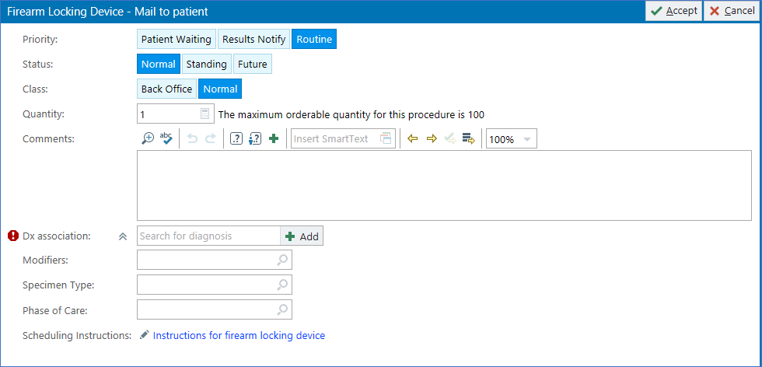
Dx: Encounter for home safety review for injury prevention; Counseling for injury prevention
- Sample scripting: I’d like to mail you a firearm cable lock with locking instructions, would that be ok? Many firearms owners store at least one firearm unlocked for self-protection purposes, and this kind of access can create problems. Locking devices can help prevent harm.
Specific types of harm prevention to reference include:
  - to oneself when we experience emotional pain and our decision-making abilities are impaired
  - to family or household members experiencing depression & thoughts about suicide
  - to children who often know the location of their parents’ hidden firearms
  - to community members when firearms are stolen from residences and cars (firearms are one of the most commonly stolen items across the U.S.)

Disappearing text in the system-level Safety Plan smarttext .SafetyPlan will remind clinicians about this option (the text disappears when clinicians sign the note)

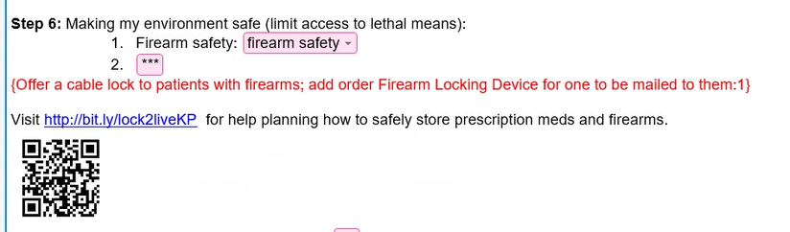


A few recommendations from our patient members…

Have an open conversation
Patients were more willing to listen and try a tool if a provider took the time to connect, showed compassion for people’s unique experiences, and showed respect for autonomy.
“So bringing it up more as like – not we’re taking it [firearm] away from you, but letting you decide what to do with it….I’m more keen to follow somebody who’s like ‘I’m offering you the opportunity to maybe do this together,’ instead of ‘I’m watching out for you.’”

“I think it's important to just take a breath, sit down with them, look them in the eye - how can I help you? What's going on? How are you feeling?”

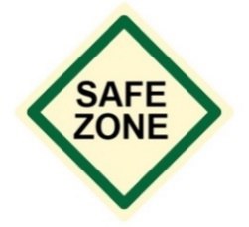
Be nonjudgmental
Understanding reasons for firearm access (self-protection) may help providers engage patients conversations about limiting access.


Make resources accessible and memorable

Have multiple routes for sharing resources (in person, secure message, after visit summary, website, pamphlet).

Share what to expect
Patients said their trusted care providers can help overcome the barrier of trying something new.

FAQs

What if people say they don’t want or need a firearm lock?
Firearm owners recommend taking a harm-reduction approach. Specific types of harm prevention are included in the sample scripting above. While firearms may make people feel safer it is also important to understand their lethality and take steps to help us protect ourselves, and members of our household and communities.
Advice to use locking devices may contradict what people learn in firearm safety trainings, which is that fast access is important when you are trying to protect your home from an intruder. Acknowledging that firearms can both increase sense of security and increase risk of harm to self and others at the same time maybe be important. It may be helpful to describe how all people have impaired decision-making abilities during “hot states” when we experience fear, emotional pain, anxiety, and it is a universal human quality to overestimate our ability to make rational decisions.
Recent surveys indicate that over half of firearm owners (58%) report storing at least one firearm unlocked and hidden for use in an emergency. People who do not use firearm locks often believe they are unnecessary or may prevent them from easily accessing their firearm in an emergency.

What if offering a firearm lock makes people upset?
Some people have strong feelings about firearm laws, but there is strong support (from firearm owners and non-owners) for suicide and injury prevention. For that reason, patients have suggested emphasizing why we are offering firearm locks—because firearm are the leading cause of death for children and teens (age 1-19) and the most common way people of all ages die by suicide.

What if people don’t like cable locks?
Cable locks are just one of many options for firearm storage. The goal of using cable locks for suicide prevention is to increase the time for someone at risk to access a firearm. Additional storage devices and safes can be purchased on Amazon and wherever firearms and accessories are sold. Discounts may be available through local public health departments and free at community give-away events. All clinics in Tacoma-Pierce County now have firearm lock boxes to give to patients from the health department.

What about other medication lock boxes, when will these be available to give to patients?
Hopefully soon as an option to order from the over-the-counter pharmacy. We are also exploring other ideas across KP regions. In the meantime, we will make these available to providers/clinical managers who request them. Contact Julie.E.Richards@kp.org to learn more.

Are firearms allowed in KPWA facilities?
No, firearms are not allowed in Kaiser Permanente facilities. We are enforcing this policy through various screening methods such as passive weapons detection systems, verbal, and visual checking. Depending on the location and nature of care needs patients may be asked to reschedule or surrender their weapon for the duration of their care.

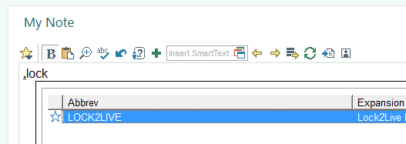
What other resources can I offer?
Lock To Live
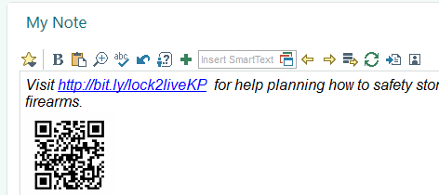
Lock2Live is a patient-facing web-based decision aid to support making decisions about lethal means. Providers can use .LOCK2LIVE to add a short URL and a QR code for easy access to this resource (i.e. in AVS or Secure Message). It is also embedded in Step #6 of .SafetyPlan (Making my environment safe).
Clinicians and patients (including firearm owners and those with suicidal thoughts) helped develop this tool. It is completely anonymous (it does not ask for/store any identifiable information).
Link to 3 minute training video: here

Firearm Storage Map
Out-of-home firearm storage can be especially helpful to people in crisis. The businesses and law enforcement agencies listed on these maps consider requests for temporary, voluntary firearm storage: 1) WA State Map 2) National Map

What else might be helpful to know about?
Voluntary Waiver of Firearm Rights (Voluntary Do-Not-Sell)
In Washington state, an individual who is concerned about suicidal thoughts may voluntarily ask to be put on a Do-Not-Sell list used during the background check process. This request is fully reversible and may happen in consultation with your medical provider. The goal is to reduce suicide risk by voluntarily and confidentially restricting immediate access to firearm purchase.
Extreme Risk Protection Orders (ERPOs)
ERPOs are non-criminalizing and allow a judge to temporarily restrict individual possession and purchase of firearms using a civil order to protect someone from harming themselves or others. In Washington State, only law enforcement, family, and household members may file an ERPO petition, but family members may ask their healthcare providers for assistance.

References
- Anestis MD, Moceri-Brooks J, Johnson RL, et al. Assessment of Firearm Storage Practices in the US, 2022. JAMA Netw Open. 2023;6(3):e231447. doi:10.1001/jamanetworkopen.2023.1447.
- Baxley F, Miller M. Parental misperceptions about children and firearms. Arch Pediatr Adolesc Med. 2006 May;160(5):542-7. doi: 10.1001/archpedi.160.5.542. PMID: 16651499.
- Federal Bureau of Investigation 2024; https://cde.ucr.cjis.gov/. Accessed June 7, 2024.
- Loewenstein G. 2005. Hot-cold empathy gaps and medical decision making. Health Psychology 24(4) Suppl. S49-S56.
- Richards JE, Kuo E, Stewart C, Shulman L, Parrish R, Whiteside U, Boggs JM, Simon GE, Rowhani-Rahbar A, Betz ME. Reducing firearm access for suicide prevention: Implementation evaluation of the web-based "Lock to Live" decision aid in routine healthcare encounters. JMIR Med Inform. 2024 Apr 22;12:e48007. doi: 10.2196/48007. PMID: 38647319.
- Richards JE, Kuo ES, Whiteside U, et al. Patient and Clinician Perspectives of a Standardized Question About Firearm Access to Support Suicide Prevention: A Qualitative Study. JAMA Health Forum. Nov 4 2022;3(11):e224252. doi:10.1001/jamahealthforum.2022.42522799032 [pii]
- Richards JE, Boggs JM, Rowhani-Rahbar A, Kuo E, Betz ME, Bobb JF, Simon GE. Patient-Reported Firearm Access Prior to Suicide Death. JAMA Netw Open. 2022 Jan 4;5(1):e2142204. doi: 10.1001/jamanetworkopen.2021.42204. PMID: 35006250.
- Richards JE, Kuo E, Stewart C, Bobb JF, Mettert KD, Rowhani-Rahbar A, Betz ME, Parrish R, Whiteside U, Boggs JM, Simon GE. Self-reported access to firearms among patients receiving care for mental health and substance use. JAMA Health Forum. 2021;2(8):e211973.
- Richards JE, Hohl S, Segal C, Whiteside U, Luce C, Grossman D, Lee AK, Ludman EJ, Simon G, Penfold R, Williams EC. What Will Happen If I Say Yes?” A Qualitative Study of Patient-Reported Access to Firearms. Psychiatr Serv. 2021 Aug 1;72(8):898-904. doi: 10.1176/appi.ps.202000187.

