
Firearm Injury & Suicide Prevention
Volunteer FAQ
Sample script: Hello, welcome! My name is [NAME]. We have some information about suicide prevention and firearm injury prevention. We also have lockboxes and cable locks to distribute. If you are interested in either of those, let me know, I’m happy to answer questions!

Page 1:
- How big of a problem are firearm injuries/deaths and suicide in WA state?
- How common is it to have firearms in your home?
- Why does KP sponsor lockbox and trigger lock giveaway events?
- What is KP’s mission?/Why does KP care?
- Who does KP partner with/how does KP choose locations for events?
Page 2:
- Are cable locks effective? Aren’t they easy to break if you really wanted to?
- If someone needs access to a firearm for safety reasons, isn’t a cable lock a bad idea?
- How do you use a cable lock? How do you use a lockbox?
- Are there places to store firearms offsite?
- Can I get a cable lock or med lock box even if I’m not a KP member/don’t have KP insurance?
- My friend couldn’t come but wants one, could I grab one for them? How many can I have?
- Where can I get more resources about firearm injury prevention/suicide prevention/free locks?

How big of a problem are firearm injuries/deaths and suicide in WA state?
- In 2021, firearm homicide was the second leading cause of injury-related death, and firearm suicide was the fourth leading cause of injury-related death for young people ages 1 to 21.²
- 72% of firearm-related deaths in Washington are due to suicide. For young people, it’s about 55% due to suicide and 45% due to homicide.³
- Every year, over 1200 people die by suicide of all causes in Washington state.⁶

How common is it to have firearms in your home?
- About 1 in 3 WA State adults report having a firearm in or around their home.¹
- Over 75% of the firearms used in suicide attempts and unintentional injuries for young people were stored in the residence of the victim, a relative or friend⁴.

Why does KP sponsor lockbox and trigger lock giveaway events?
KP believes that even 1 preventable injury or death due to firearm suicide, homicide, and unintentional injury is too many. We consider it a public health issue. So just like we promote health clinics, mammogram screenings, bike helmet giveaways. We promote secure firearm storage with free cable lock/lockbox giveaway events like this one.

What is KP’s mission?/Why does KP care?
Kaiser Permanente exists to provide high-quality, affordable health care services and to improve the health of our members and the communities we serve, and we focus on total health. \This safe firearm storage program is focused on education and awareness building. We advocate for safe firearm storage in homes, because we want to help prevent firearm-related incidents in our communities.

Who does KP partner with/how does KP choose locations for events?
Kaiser Permanente tries to collaborate with as many local organizations as we can. We want to create a culture of safe firearm usage in our communities. We work with partners to choose locations we think will reach people in our communities so we can get this information out there to as many folks as possible.

Are cable locks effective?/Aren’t they easy to break if you really wanted to?
Cable locks are very effective to prevent youth from accidental access and injury. It’s also a good way to allow someone in crisis an extra moment before making an impulsive decision. Safe storage reduces risk of firearm suicide by up to 78% and accidental shootings by up to 85%.⁵ It’s effective for adults too.

If someone needs access to a firearm for safety reasons, isn’t a cable lock a bad idea?
A cable lock only takes a little bit of time to remove if you need your firearm. The risk from accidental access or access when in crisis leading to harm is much higher than the risk of slightly delayed access.
How do you use a cable lock?
The lock works very similarly to a bike lock. And it comes with instructions. You can also watch a video.

How do you use a lockbox?
It’s easy to use, just a 3 digit combo that you set. It comes with instructions, and there’s a QR Code for them too, in multiple languages.
Can I get a cable lock or med lock box even if I’m not a KP member/don’t have KP insurance?
Yes! This is a community giveaway event for anyone who wants one.

My friend couldn’t come but I know they could use one, could I grab one for them?
How many cable locks/med lock boxes can I have?
There’s no limit on how many cable locks you can take. You can take up to 1 lock box per adult.

Are there places to store firearms?
WA state has a firearm safe storage map website https://hiprc.org/firearm-storage-wa/ (see QR code)
Anonymous storage ideas for lethal means: Lock2live https://lock2live.org/ https://es.lock2live.org/

Where can I get more firearm injury prevention resources?
(see the flyer stand for QR Codes)
Local guide: King County Community page
National guide: https://www.bulletpointsproject.org/

Where can I get more resources about suicide prevention?
Free, 24-hour support if you or someone you know is in crisis: call/text 988
https://988lifeline.org/  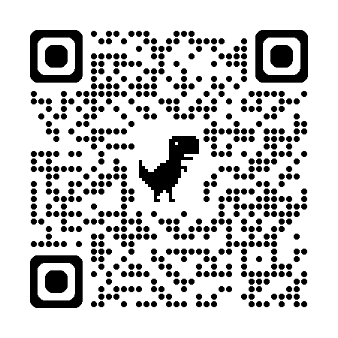 | https://988lifeline.org/es/inicio/  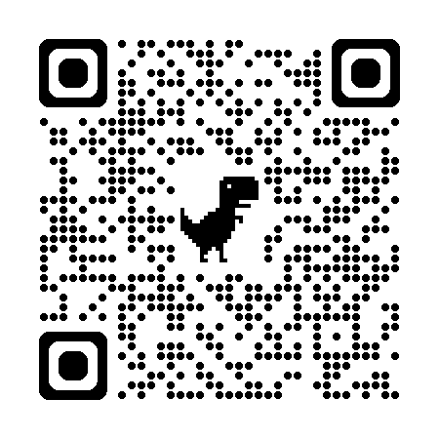 | Nowmattersnow.org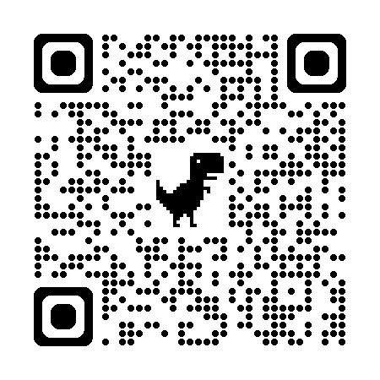

Materials plan
Before you come | KP T shirts mailed to your home – please wear the KP one with the SKCC one over it each time you come!  Please read this FAQ and look through the QR codes on the back of this sheet so you have some familiarity with the booth contents
Day of | Check in by 5:AM or 8:30AM at Fisher Pavillon Don’t wait in line  - Go to the volunteers at the doors and introduce yourself as a Community Table provider. Do not use the word volunteer  - You will receive your volunteer badge, clinic t-shirt, and meal voucher. Please check in everyday to be marked in the system and receive your meal voucher for the day.  Text the lead if you are sick and unable to attend:  - Thursday/Friday Julie: 206-898-1653  - Sat/Sun Erika: 206-697-3033  - Noon/Haley backups N: 206-240-5775 ~ H: 206-573-8043  - (Lead Text Olivia if someone needs to be added 206.293.2067)
Day of on table  (stored under table unless noted to get from store room) | KP tablecloth  3 KP baskets (see below)  5 flyer stands (see below)  Lots of brochures (see below)  Lock boxes – 25 per day take from the onsite storage room  Tracking sheet to track how many folks come by the booth
In baskets | 1.988 stickers/swag  2. Cable locks– 250 per day per day take from onsite storage room  3. Thrive Backpacks – 500 per day per day take from onsite storage room
In flyer stands | - Safe Storage options  - Cable lock instructions  - lockbox instructions  - Firearm injury prevention resources  - Suicide prevention resources
Other Brochures | - General Suicide prevention flyer  - 10 minutes can save a life flyer 1 pager  - Other Brochures in multiple languages
End of day | Lead Complete tracking sheets; give to Daytime manager Jerin.  Put extra lockboxes into storage room  Put extra swag under the table  Leave flyers on the table

References
1. Morgan ER, Gomez A, Rowhani-Rahbar A. Firearm Ownership, Storage Practices, and Suicide Risk Factors in Washington State, 2013-2016. Am J Public Health. 2018 Jul;108(7):882-888.
2. Leading Causes of Death Visualization Tool, 2021, accessed December 2023
3. CDC WISQARS Explore Fatal and Nonfatal Data, 2019-2021, accessed December 2023
4. Grossman, et al., Self-Inflicted & Unintentional Firearm Injuries Among Children & Adolescents: The Source of the Firearm, August 1999
5. Grossman DC, Mueller BA, Riedy C, et al. Gun Storage Practices and Risk of Youth Suicide and Unintentional Firearm Injuries. Journal of the American Medical Association. 2005; 293(6):707-714.
6. https://www.cdc.gov/nchs/pressroom/sosmap/suicide-mortality/suicide.htm

Washington state has a firearm safe storage map website  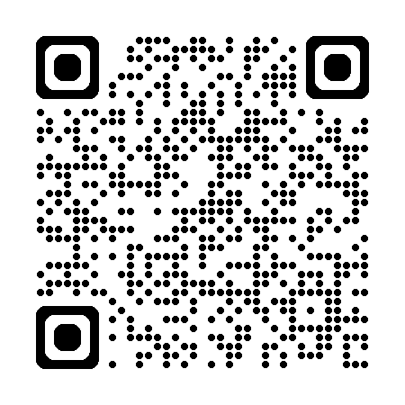 | 5 min Video about safely storing firearms  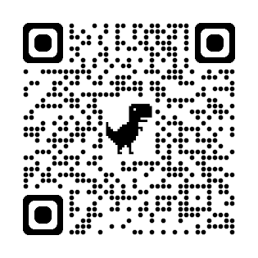
How to use a lock box English  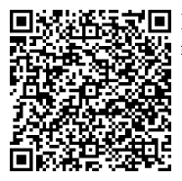 | Anonymous website with ideas on storage for lethal means Lock2Live https://lock2live.org/  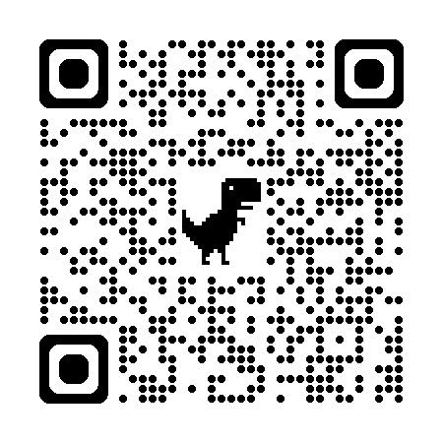
How to use a lock box Español  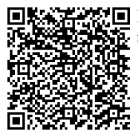 | Lock2Live en Español https://es.lock2live.org/  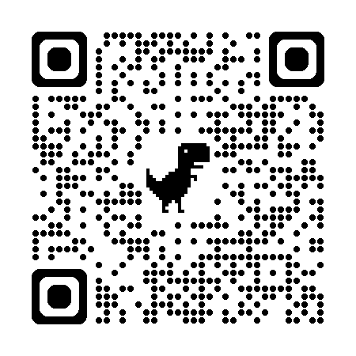
How to use a lock box Other Languages  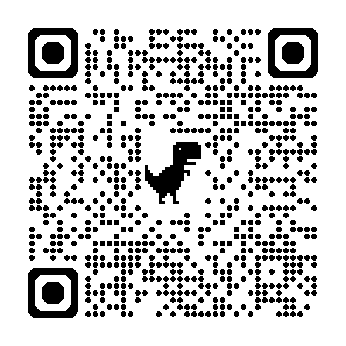 | How to use a cable lock  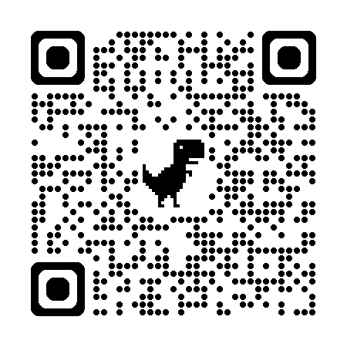
Local Firearm injury prevention resources: King County Community page  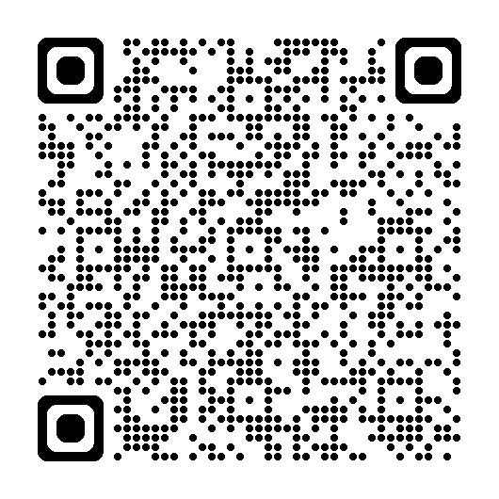 | National Firearm injury prevention resources https://www.bulletpointsproject.org/  