Washington state has a firearm
safe storage map website
https://hiprc.org/firearm-storage-wa/
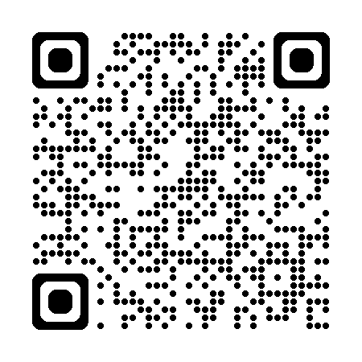

Anonymous website with ideas on
storage for lethal means called Lock2Live
https://lock2live.org/ https://es.lock2live.org/
English Español
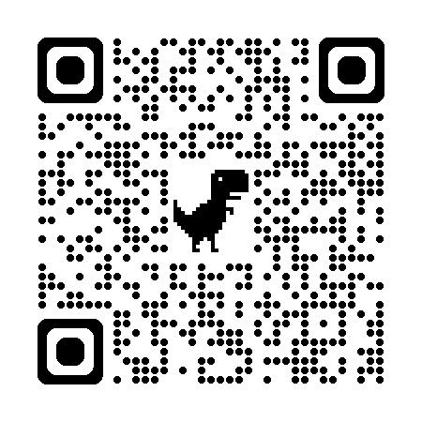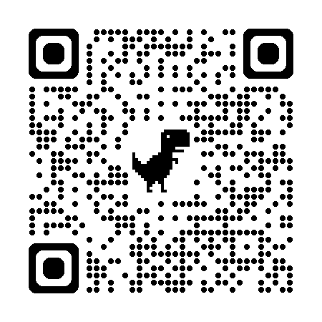
How to use a lock box
English
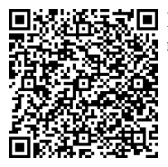

Español
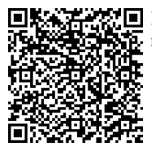

Other Languages
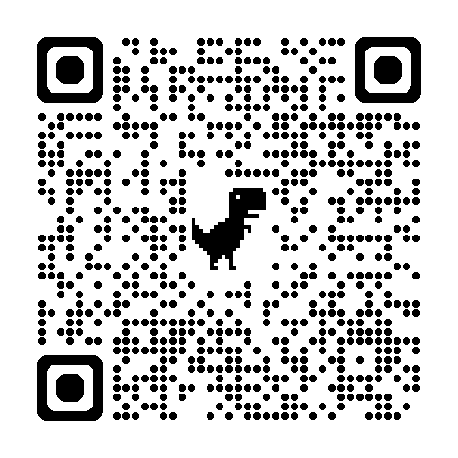

1 min Video: How to use a cable lock
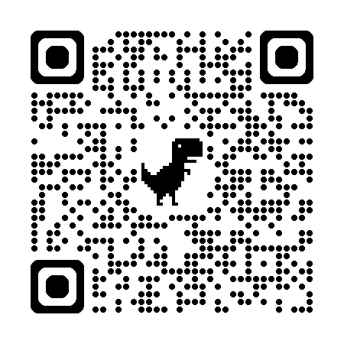

5 min video: Safely storing firearms
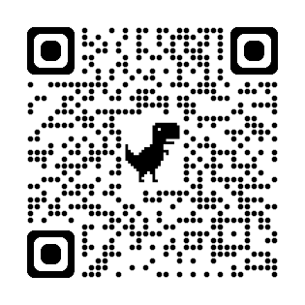

Firearm injury prevention resources

Local guide: King County Community page
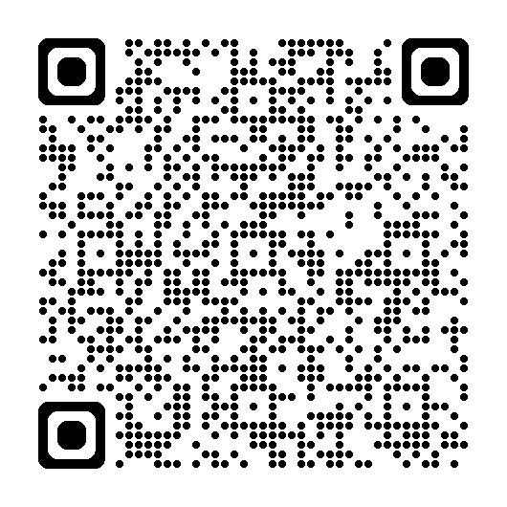

National guide: https://www.bulletpointsproject.org/

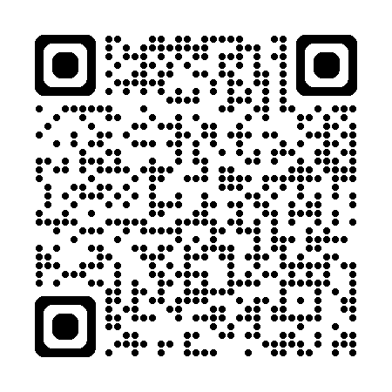

Suicide prevention Resources

Free, 24-hour support if someone is in crisis:
call/text 988
https://988lifeline.org/ https://988lifeline.org/es/inicio/
English Español

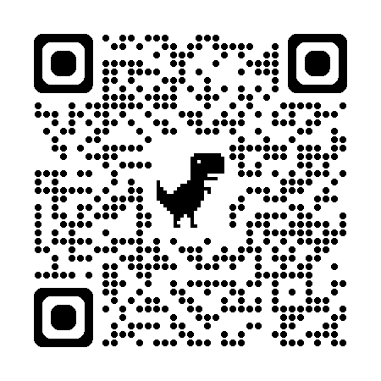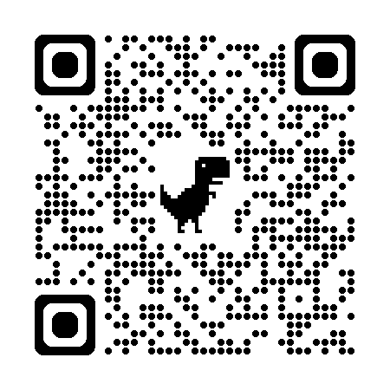

nowmattersnow.org
