
Firearm Lock Giveaway events
Sponsored by KPWA
Overview and FAQ

Who we are:
We are a team of Kaiser Permanente Washington researchers, providers, and staff who care deeply about firearm injury prevention.

What we provide during an event:
- Firearm cable locks, that work somewhat like a bike lock. We also sometimes have lockboxes for medications. (See pics below).
- A computer with videos that demonstrate how to use cable locks and overviews.
- Flyers in multiple languages about suicide and firearm injury prevention, stickers with 988 crisis hotline number, other information to support harm reduction, and QR codes for accessing information digitally.
- We often provide KP swag, including tote bags to hold locks and flyers from the event and increase privacy.
- Trained volunteers to answer questions and hand out materials.

How giveaway events work:
- Months/weeks before the event: Someone from [team doing the event] will work with you to sort out logistics like location, space, tables/chairs, materials, timing, volume expected, number of volunteers, badges etc.
- Right before the event: We will come and do our own set up and staging of materials.
- During the event: We will staff the booth ourselves, and we will have multiple volunteers on hand to distribute cable locks, medication lock boxes and answer questions.
- After the event: We will take down the booth and remove any unused flyers and materials.

How cable locks and lockboxes work:
Cable locks work similarly to a bike lock, with a key. It comes with instructions, and we have a video.
Medication lock boxes allow you to set a 4-digit combination lock. It comes with instructions.

For more information, please contact [name of point person].

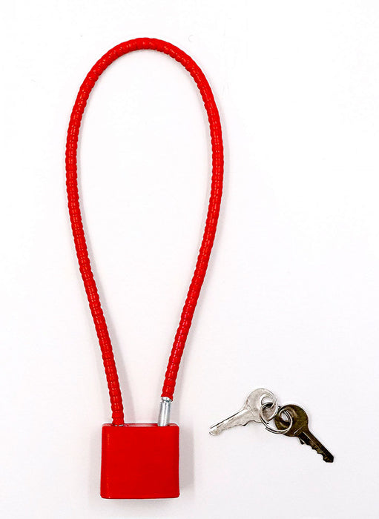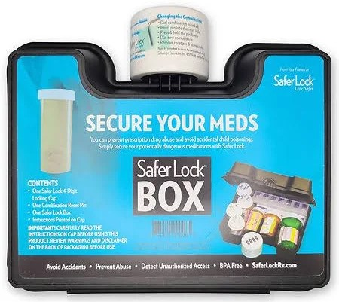
FAQ
How common is it to have firearms in your home?
- About 1 in 3 WA State adults report having a firearm in or around their home.¹
- Over 75% of the firearms used in suicide attempts and unintentional injuries for young people were stored in the residence of the victim, a relative or friend⁴.

How big of a problem are firearm injuries/deaths and suicide?
- In 2021, firearm homicide was the second leading cause of injury-related death, and firearm suicide was the fourth leading cause of injury-related death for young people ages 1 to 21.²
- 72% of firearm-related deaths in Washington are due to suicide. For young people, it’s about 55% due to suicide and 45% due to homicide.³
- Every year, over 1200 people die by suicide of all causes in Washington state.⁶

Why does KP sponsor firearm safety giveaway events?
KP exists to provide high-quality, affordable health care services and to improve the health of our members and the communities we serve. We advocate for safe firearm storage, because we want to help prevent firearm injuries in our communities. KP believes that even 1 preventable injury or death from firearm suicide, homicide, and unintentional injury is too many and we consider it a public health issue. So just like we promote health clinics, mammogram screenings, bike helmet giveaways, we promote secure firearm storage with free events.

How does KP choose partners and event locations?
We try to collaborate with as many local organizations as we can to help create a culture of safe firearm usage in our communities. We work with partners to choose locations that will help get this information out there to as many folks as possible.

Are cable locks effective? They can be broken/opened quickly.
Cable locks are very effective to prevent youth from accidental access and injury. It’s also a good way to allow someone in crisis an extra moment before making an impulsive decision. Safe storage reduces risk of firearm suicide by up to 78% and accidental shootings by up to 85%.⁵ It’s effective for adults too.

If I need firearm access for safety, isn’t a cable lock a bad idea?
A cable lock only takes a little bit of time to remove if you need your firearm. The risk from accidental access or access when in crisis leading to harm is much higher than the risk of slightly delayed access.
Can anyone get locks, even if they don’t have KP insurance?
Yes! Our community giveaway events are open everyone in the community.

Where can I get more resources?
WA state firearm safe storage map website https://hiprc.org/firearm-storage-wa/
Local guide to Firearm injury prevention: King County Community page
National guide to Firearm injury prevention: https://www.bulletpointsproject.org/
Free, 24-hour crisis hotline: call/text 988 https://988lifeline.org/
Nowmattersnow.org for suicide prevention resources
Anonymous decision tree for ideas on storing lethal means: Lock2live https://lock2live.org/

References
1. Morgan ER, Gomez A, Rowhani-Rahbar A. Firearm Ownership, Storage Practices, and Suicide Risk Factors in Washington State, 2013-2016. Am J Public Health. 2018 Jul;108(7):882-888.
2. Leading Causes of Death Visualization Tool, 2021, accessed December 2023
3. CDC WISQARS Explore Fatal and Nonfatal Data, 2019-2021, accessed December 2023
4. Grossman, et al., Self-Inflicted & Unintentional Firearm Injuries Among Children & Adolescents: The Source of the Firearm, August 1999
5. Grossman DC, Mueller BA, Riedy C, et al. Gun Storage Practices and Risk of Youth Suicide and Unintentional Firearm Injuries. Journal of the American Medical Association. 2005; 293(6):707-714.
6. https://www.cdc.gov/nchs/pressroom/sosmap/suicide-mortality/suicide.htm

